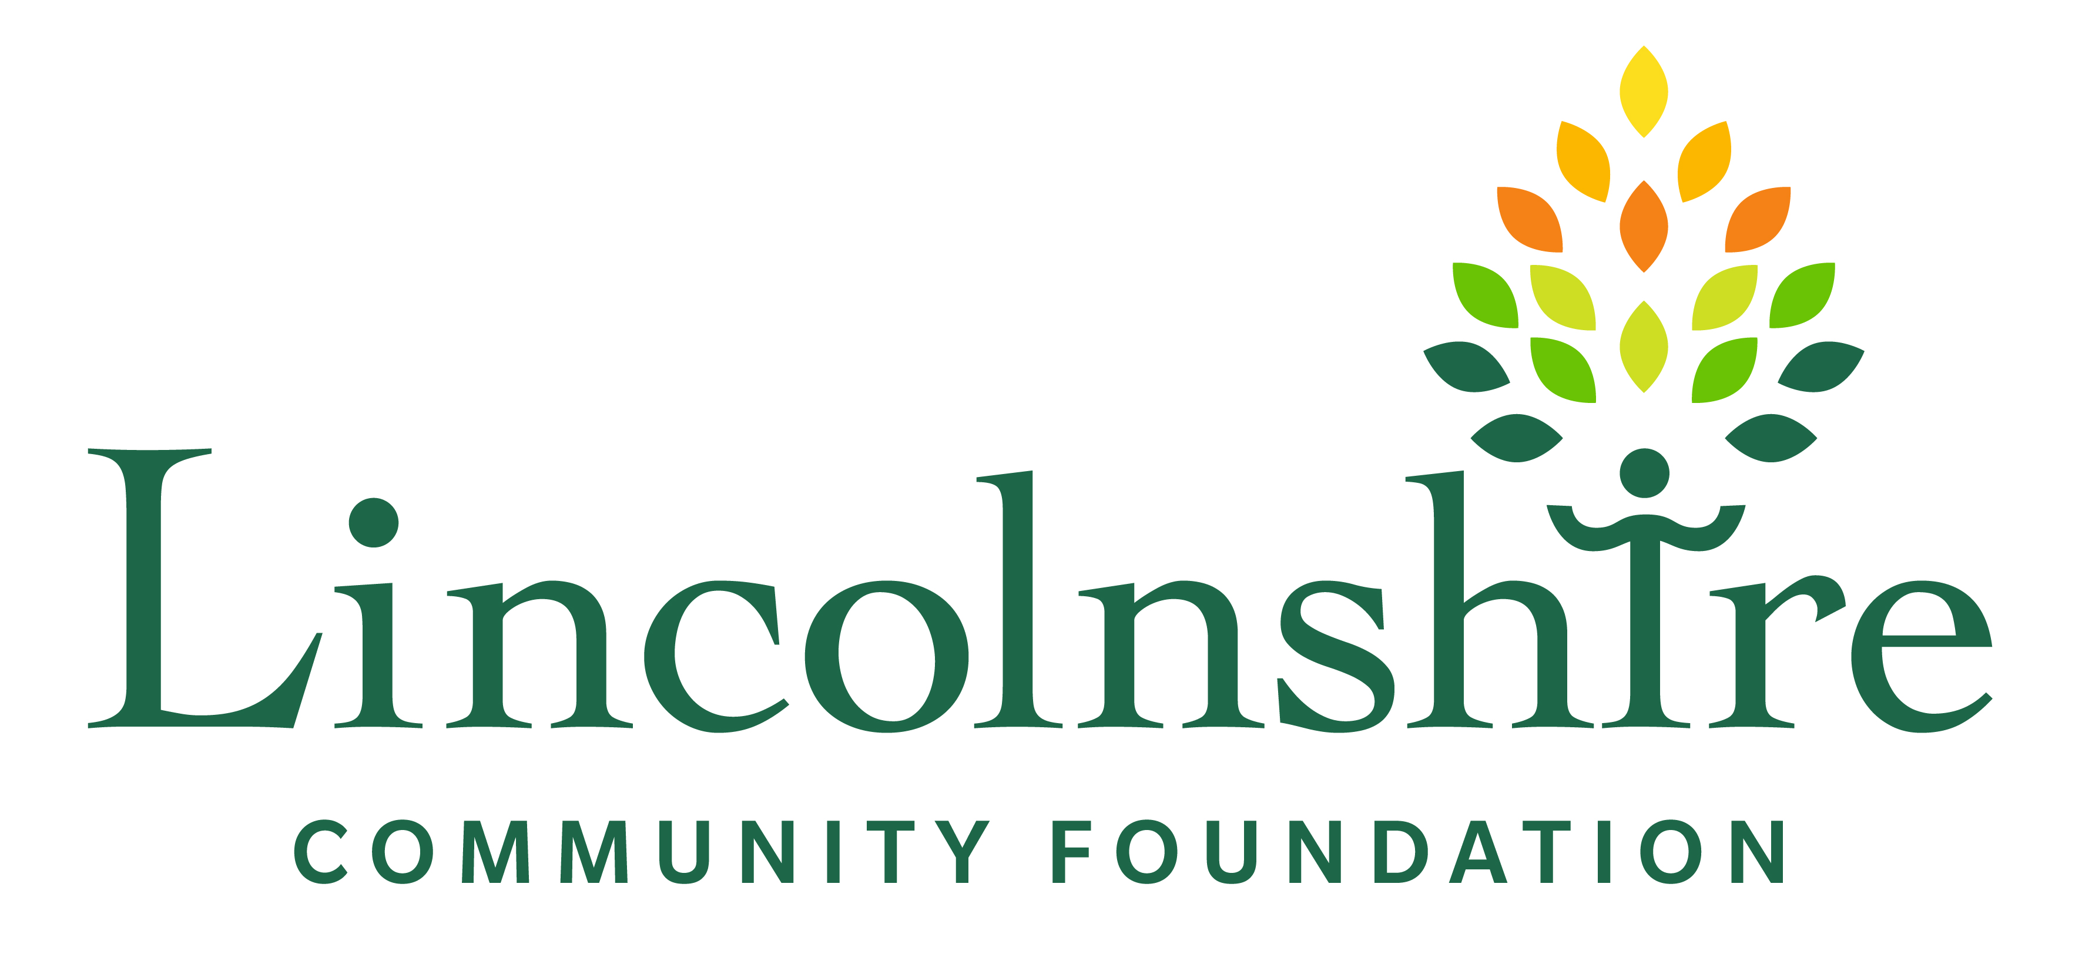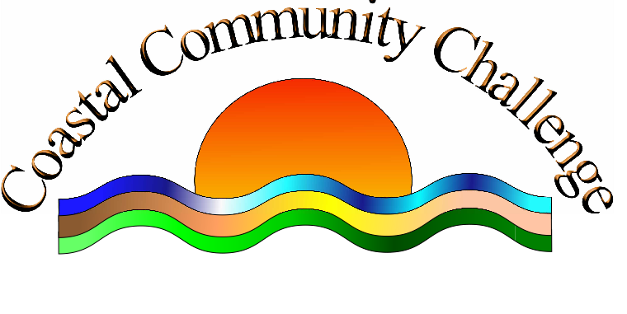

PRIOR TO COMPLETING THE APPLICATION, PLEASE REFER TO GUIDELINES BELOW
The Partnership has reflected on funds available and a decision has been taken to limit grant funding requests up to £500 at any one time.

GRANT APPLICATION FORMrm | return to  Lincolnshire Community Foundation  4 Mill House, Carre Street, Sleaford, Lincs. NG34 7TW  01529 305825 www.lincolnshirecf.co.uk
Name of Group or Project:
Contact Name and Position

Address
Telephone
Email/website
Project Summary:
What you would like funding for? Give the project start and finish dates, why it is needed. How will you know if the project has been a success? Is there anything similar available locally?

add extra sheet if necessary
Project Management:
Describe group structure (charity, club etc); details of committee or trustees; when the group started, no of staff/ volunteers.
copy of rules or constitution
charity number if applicable

Finances:

Details of group’s income and expenditure; bank account and signatories. Has your group received any grants in the last 2 years? If so, please let us have details?
copy of group’s accounts or budgets

Referee:

Contact details of one referee -prominent in your local community.
Who will the
project help:

Number, type, location of beneficiary.
Outline of
project costs:
How much you want from us (maximum £500); if there is a shortfall, how will you raise the rest? Have you applied to any other funder for a grant towards the project costs? Please provide full details.

Wherever possible, please provide evidence of cost.
How the project will continue when
funding ends:
Explain, if applicable (this may be a one-off project).

Guidelines
The Object of the Fund is to improve the health and wellbeing of people living in the LN12 area (Mablethorpe, Trusthorpe and Sutton on Sea).

Eligibility
Not for profit community groups can use this form to apply for up to £500. All applicants should submit:-
- Constitution/Governing Document (advice available);
- Income and Expenditure Account (or last three months Bank Statements, if a new group);
- Quotes to support any cost over £100;
- Evidence that the balance of project costs are in place;
- Any additional information (photos, leaflets, maps etc);

What can be funded:
- Community consultation costs;
- Pilot projects;
- Projects that promote a healthy lifestyle or improve health and wellbeing;
- Projects that support harmony and integration in the community;
- New or replacement equipment;
- One off events/activities (fund for outings is unlikely to be awarded unless the applicant can show evidence of need or long term benefits)
- Venue hire/sessions support costs.
Applications for funding towards the cost of hosting an event should be made at least three months’ prior the event taking place and will be discussed at the next partnership meeting. Where a grant has been awarded, the CCC logo must be display on ALL promotional material.
Applicants should demonstrate they have attracted match funding, or at least show they have tried to do so.

What cannot be funded:
- Wages;
- Projects that are the responsibility of the Local Authority;
Retrospective funding;
- Projects promoting religious or political beliefs;
- Individuals;
- Project that benefit people outside of the LN12 area.

Contact Us
For further information, please contact: Sue Fortune, Lincolnshire Community Foundation, 4 Mill House, Carre Street, Sleaford, NG34 7TW - T: 01529 305825: email: sue@lincolnshirecf.co.uk

Conditions
Please sign below to indicate your acceptance of a grant from CCC Big Local in the event it is successful:

1. The Grant, administered by the Lincolnshire Community Foundation (LCF), will be used for the purpose outlined in the application. Any changes to the project must be agreed with LCF.

2. We will spend the grant within one year of its receipt or any other timetable set by LCF and will complete and submit an End of Grant Report within two months of having spent the grant money. Failure to do so, may jeopardise the success of any future funding applications.

3. Any grant money not spent on the project will be repaid to LCF.
4. We will not dispose of grant-aided equipment without LCF agreement. Any money thus raised will be refunded to LCF.

5. We will not change our rules, aims or constitution without LCF agreement.

6. We will use the Big Lottery and CCC logo in all promotional material relating to the funded project and acknowledge Big Local Trust in relevant publicity and publications, as well as acknowledging this funding via our social media networks (Facebook, Twitter etc).

7. We accept that LCF and CCC Big Local may use our project for publicity purposes and, where appropriate, display a plaque acknowledging the support.

9. We will keep all receipts and accounts relating to grant-aided expenditure for two years from receipt and send copies to LCF with the completed End of Grant Report.

10. We will not bring the fund, or LCF, into disrepute and undertake to return all funding should it be determined that we have done so.

11. We confirm that if relevant we have a valid Safeguarding Policy.

12. LCF will require repayment of all or part of the grant if the project is abandoned for any reason or if there is non-compliance with any of these conditions.

Signature: ______________________________________________
Position in group: ______________________________________________
Date:

