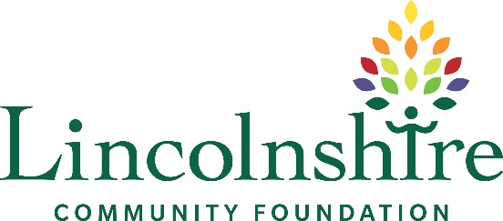

Equal Opportunities Monitoring Form

Lincolnshire Community Foundation is committed to promoting equality, diversity and inclusion. To help us understand how well we are reaching different groups, we ask all applicants to complete this form.
This information:
- is optional
- will be anonymised
- will not be seen by the selection panel
- will be used only for monitoring and improving recruitment practices

What is your age group?
☐ Under 25
☐ 25–34
☐ 35–44
☐ 45–54
☐ 55–64
☐ 65+
☐ Prefer not to say

What is your gender identity?
☐ Female
☐ Male
☐ Non-binary
☐ Prefer to self-describe: __________
☐ Prefer not to say

Is your gender identity the same as the sex you were assigned at birth?
☐ Yes
☐ No
☐ Prefer not to say

What is your ethnic background? (Please select the option that best describes your ethnic background)
- White:
☐ British
☐ Irish
☐ Gypsy or Irish Traveller
☐ Other: _______

- Mixed:
☐ White and Black Caribbean
☐ White and Black African
☐ White and Asian
☐ Other: _______

- Asian:
☐ Indian
☐ Pakistani
☐ Bangladeshi
☐ Chinese
☐ Other: _______

- Black:
☐ African
☐ Caribbean
☐ Other: _______

- Other:
☐ Arab
☐ Other: _______
☐ Prefer not to say

Do you consider yourself to have a disability? (A disability is defined as a physical or mental condition that has a substantial and long-term impact on your ability to carry out normal day-to-day activities.)
☐ Yes
☐ No
☐ Prefer not to say

Do you have any long-term health conditions?
☐ Yes
☐ No
☐ Prefer not to say

What is your sexual orientation?
☐ Heterosexual
☐ Gay/Lesbian
☐ Bisexual
☐ Other: _______
☐ Prefer not to say

Religion or Belief
☐ No religion
☐ Christian
☐ Muslim
☐ Hindu
☐ Sikh
☐ Jewish
☐ Buddhist
☐ Other: _______
☐ Prefer not to say

Do you have caring responsibilities? (e.g. for children, older relatives, or others who depend on you)
☐ Yes
☐ No
☐ Prefer not to say

Socio-economic Background
- What type of school did you mainly attend between ages 11–16?:
☐ State-funded school
☐ Independent/ fee-paying school
☐ Outside UK
☐ Prefer not to say
- Were you eligible for free school meals at any point during your schooling:
☐ Yes
☐ No
☐ Not applicable
☐ Prefer not to say

How did you hear about this role?
☐ CharityJob
☐ LinkedIn
☐ Website
☐ Recruitment agency
☐ Word of mouth
☐ Other: _______

Do you require any reasonable adjustments for interview?
☐ Yes (please specify): _______
☐ No
Thank you for completing this form. Your responses will remain confidential and will only be used in an anonymised format.

