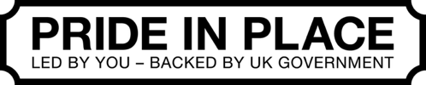
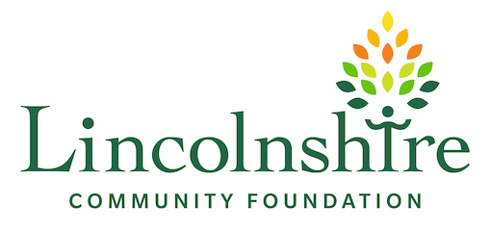
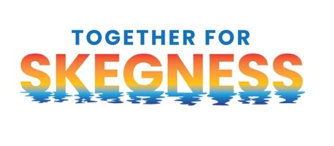

Together for Skegness Community Chest Fund
Application Form for individuals and informal community groups - up to £300
You do not need to be a charity or formal group. If you have a good idea that will benefit people in Skegness, we want to hear from you.
Need help with the form? Contact Cavan Collins or Laura Baltulyte on 01529 305825 or skegnesspip@lincolnshirecf.co.uk
Your Details

As the applicant, please provide details of the person completing this form. If you are applying as an individual, you can leave the next section (your organisation) blank.
I am applying as:
Individual | ☐
Organisation | ☐

Full name (including title)
Address:
Contact telephone number(s)
Email address

Organisation Details (if applicable)
Details
Name of Group / Organisation
Email address of Group / Organisation
Address of Group / Organisation

Postcode of Group / Organisation
Telephone of Group / Organisation
When did the organisation start?

Tell us your idea

What would you like to do?
Please give full details including where it will happen, and roughly when.

Why is it a good idea for Skegness?
Please give full details including Who will benefit? About how many people? What difference will it make?

Who will be involved?
Please give full details including who will help make it happen. This could include neighbours, friends, volunteers or a local organisation.

What will it cost?

Tell us what you need. Estimates, screenshots, web links or quotes are fine. The most you can ask for is £300. You do not need match funding.

What do you need to buy or pay for? | Approx. cost | Where can it be bought / evidence of cost

Amount requested from the Community Chest:
If your idea costs more than £300, briefly tell us how the rest will be covered:

What is the total cost of the project? | £
How much are you applying for? | £
Is there a shortfall in funds? If yes, how much? | Yes | No | £
If yes, how will you raise the balance of funds?
Have you applied to any other funder for a grant towards the project costs? Please provide full details.

How costs will be paid
Funding will not be paid into your personal account. If your idea is approved, Lincolnshire Community Foundation (LCF) will agree the easiest way to pay for it with you. Usually:

- LCF will order or pay for the agreed items or services directly; or
- A suitable local organisation will hold and manage the funding for your project.

You do not need to have a partner organisation before you apply. LCF can help with this if one is needed.

Anything else we should know?

Optional – use this space for anything else that would help us understand your idea

Your declaration

I confirm that the information I have provided is accurate and that the project is for community benefit, not personal or private benefit. I understand that LCF or a partner organisation will arrange payment of approved project costs and that I will provide a short update afterwards on what happened

Name of person completing this form:
Signature:
Date:
.

Together for Skegness Community Chest Fund
Fund Guidelines for individuals and informal community groups - up to £300

What is the Community Chest?
Small grants of up to £300 for individuals and informal or non-constituted community groups with an idea that will benefit people in Skegness. The fund is intended to help turn local ideas into action.

What kinds of ideas can we support?
Your idea should support at least one of the Skegness Pride in Place priorities. You do not need to decide which one before applying — LCF can help.
- Pride, culture and aspiration - activities, events or celebrations, volunteering, heritage, arts and culture that strengthen pride in Skegness and provide more opportunities throughout the year.
- Education, skills and opportunity - skills, digital inclusion, employability, mentoring, enterprise and activities that improve opportunities for people of all ages.
- Wellbeing, inclusion and community resilience - reducing isolation, improving physical or mental wellbeing, brining communities together and strengthening local voluntary and community organisations.
- Safe and welcoming neighbourhoods – initiatives that improve community safety, help address anti-social behaviour or make neighbourhoods and public spaces feel safer and more welcoming
- Community assets, environment and green spaces - improving community facilities, hubs, gardens and outdoor spaces, including projects that make Skegness cleaner, greener and more attractive.
- A vibrant and connected town centre - increasing participation and footfall, animating places, improving accessibility and connections, and brining residents, community groups and local businesses together.

The main things we will look for
- A clear community benefit for people in Skegness.
- A simple, realistic plan that can be delivered.
- Evidence that local people want or will benefit from the idea.
- Reasonable costs and value for money.
- No unnecessary duplication of something already available locally.

How payment works
Awards will not be paid directly to individuals. LCF will either arrange and pay for approved items or services, or work with a suitable organisation that can hold and manage the funding. LCF will discuss the best option with successful applicants
A few important things to know
- You can apply for up to £300 for revenue costs.
- You do not need match funding.
- Closing date is on 1 December 2026.
- Applicants will normally be told the decision within six weeks of the closing date.
- Projects must be completed and reported by the agreed deadline and no later than 31 March 2028.

We cannot normally support
- Personal or private benefit, personal debts, deficits or loans.
- Costs already incurred before a grant is agreed.
- General contributions to large appeals.
- Projects promoting religious or political beliefs. Activities connected to places of worship may be considered where they are open and welcoming to the wider community.
- Activity that simply duplicates something already available locally without adding value.
- Projects that cannot be completed and reported by the agreed deadline.

How to apply
Send this form to skegnesspip@lincolnshirecf.co.uk. If email is difficult, post it to: Together for Skegness Community Chest Fund, Lincolnshire Community Foundation, Glennys Sanders House, Pride Parkway, Sleaford, Lincolnshire, NG34 8GL.
If you would rather talk through your idea before filling in the form, please contact Cavan Collins or Laura Baltulyte on 01529 572577or skegnesspip@lincolnshirecf.co.uk

